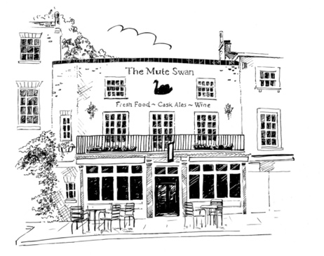
The Mute Swan
Garden Festival Breakfast Menu*

Full English, bacon, sausage, black pudding, mushrooms, tomato, hash brown, beans,
fried eggs (gfa) 972 kcal 14.95
Vegetarian full English, sausages, mushrooms, tomatoes, hash brown, baked beans,
fried eggs (v, gfa) 925 kcal 12.95
Eggs Benedict, honey roast ham, soft poached egg, hollandaise sauce 630 kcal 10.95
Eggs Florentine, buttered spinach, soft poached egg and Hollandaise sauce (v) 588 kcal 8.95
Eggs Royale, smoked salmon, soft poached egg, hollandaise sauce 513 kcal 11.95
Shakshuka; baked egg in spiced tomato, pepper and onion sauce, Greek yogurt, ciabatta (v) 625 kcal 9.95
Pecorino, truffle and potato hash brown, wild mushrooms, spinach, poached egg, hollandaise (gf) 621 kcal 11.95
Summer berries, Greek yoghurt, granola (v, gf) 279 kcal 6.95

*This is a sample menu, and some dishes or ingredients may change.
The final menu will be available with full allergen information from 1st July

